1. Sprint Details

Sprint 1 - Foundation (3 days)

Goals
- Project setup, repository structure, MongoDB connection
- User authentication (register, login, JWT)
- Project CRUD API
- Basic Next.js frontend scaffolding

Deliverables
Task | Owner | Status
FastAPI project setup + folder structure | Backend Lead | Done
MongoDB connection via Beanie ODM | Backend Lead | Done
User model (email, username, hashed_password) | Backend Lead | Done
Project model (7 stage fields) | Backend Lead | Done
User routes: register, login, get, update, delete | Backend Lead | Done
JWT auth (bcrypt, python-jose) | Backend Lead | Done
Next.js 16 App Router scaffold | Frontend Lead | Done
Environment config (pydantic-settings + .env) | DevOps Lead | Done

Sprint 1 - Sequence diagram
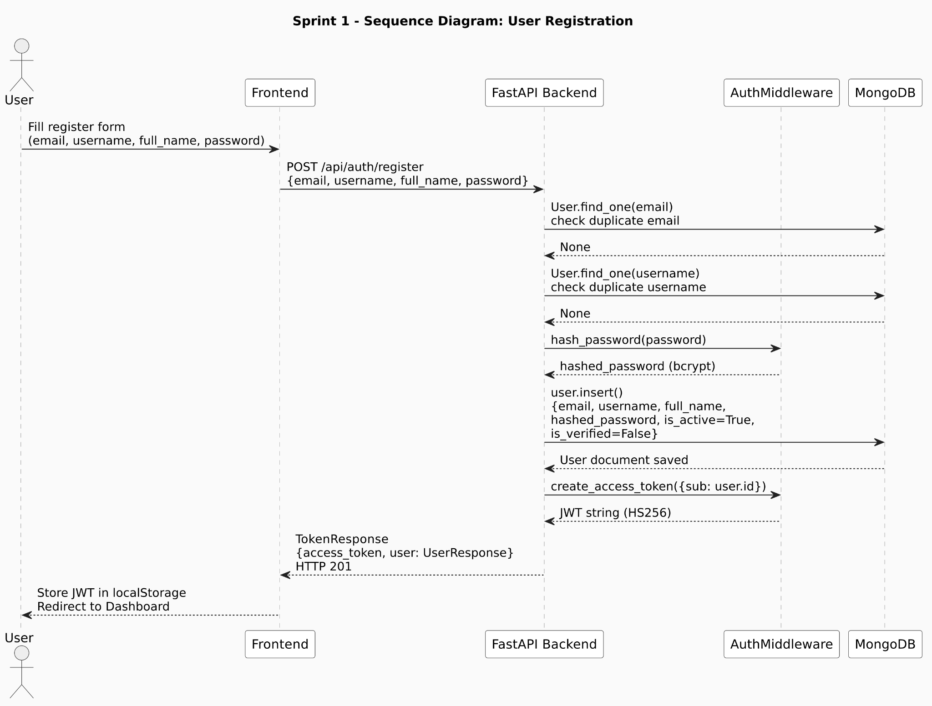

Sprint 1 - Class diagram
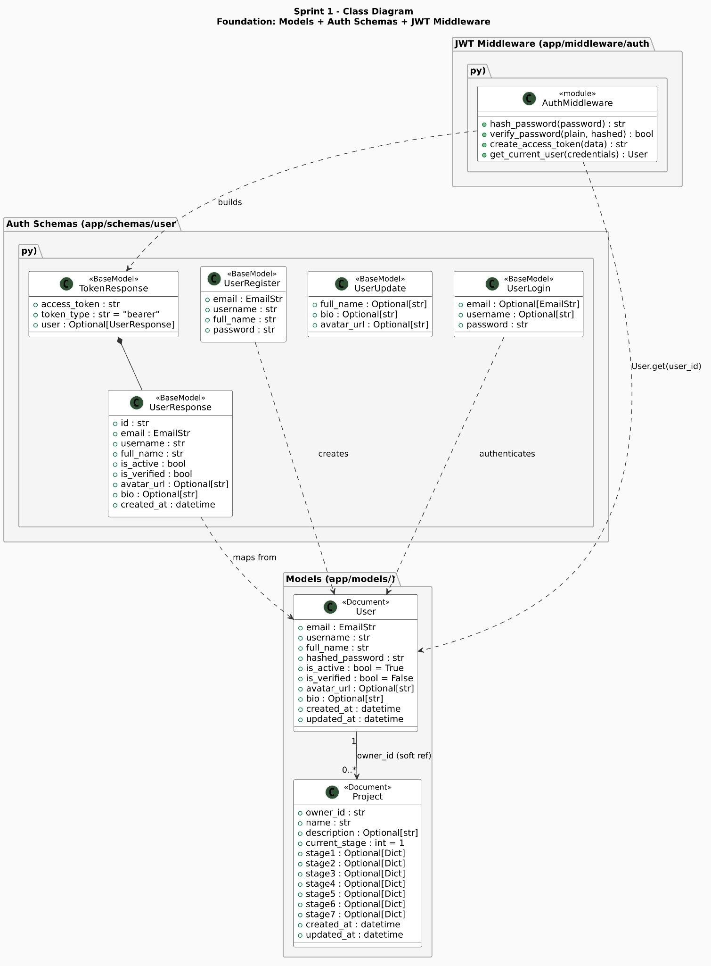
Sprint 2 - Stage 1 and 2 pipeline (1 week)

Goals
- Discovery Gate LLM chat loop with readiness scoring
- Product Vision Document generation
- Feature Mapping (Epic generation + toggle)
- Frontend: Chat UI + readiness progress bar + Epic checklist

Deliverables
Task | Owner | Status
Stage 1 chat endpoint (POST /stage/1/chat) | Backend Lead | Done
Pillar extraction via structured LLM output | Backend Lead | Done
Readiness score calculation logic | Backend Lead | Done
PVD generation when score >= 0.85 | Backend Lead | Done
Stage 2 epic generation endpoint | Backend Lead | Done
Stage 2 epic selection (PATCH /stage/2/select) | Backend Lead | Done
Frontend: Stage 1 chat interface | Frontend Lead | Done
Frontend: Readiness score progress bar | Frontend Lead | Done
Frontend: Stage 2 epic card checklist | Frontend Lead | Done
Sprint 2 - Sequence diagram
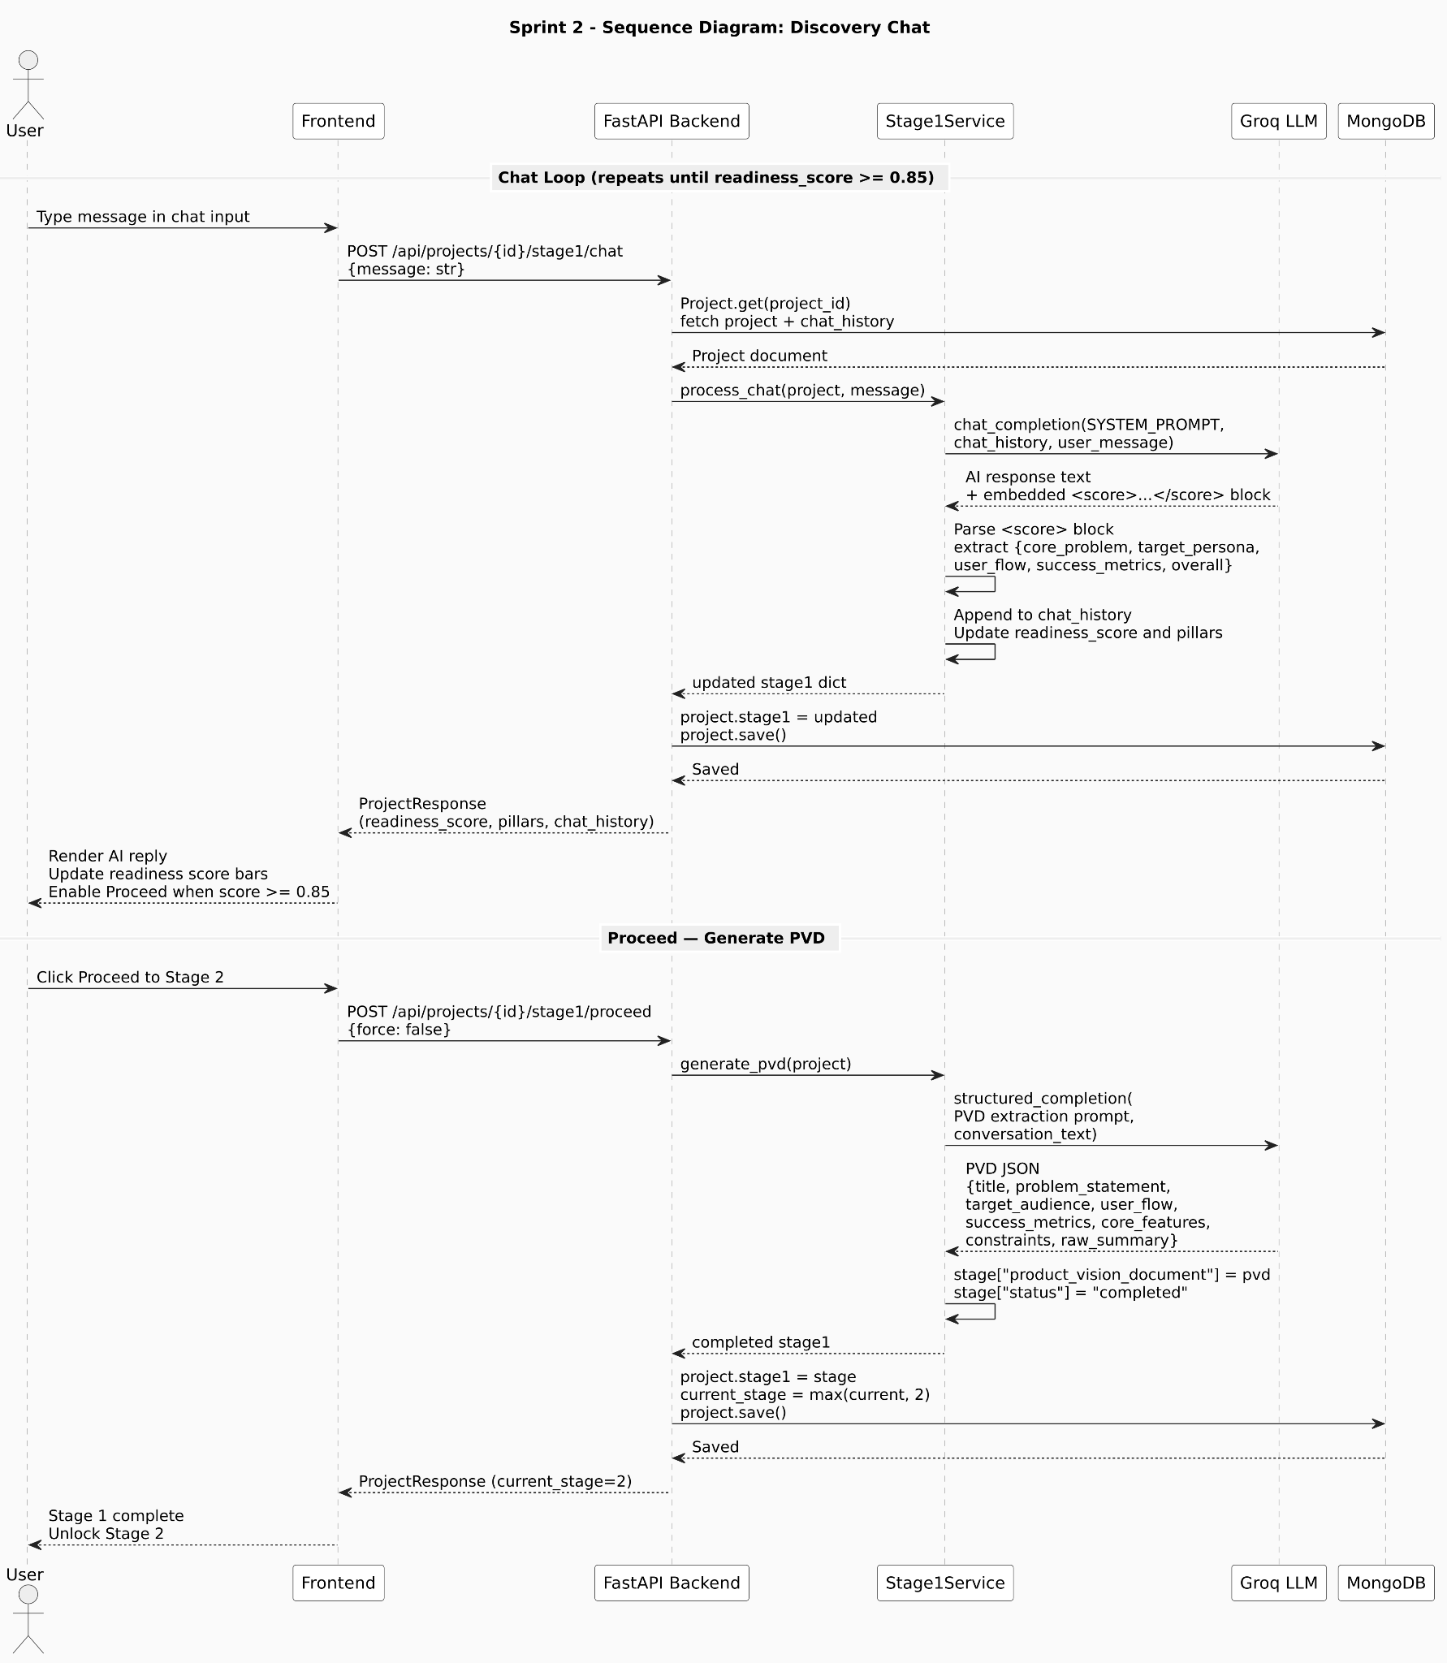
Sprint 2 - Class diagram
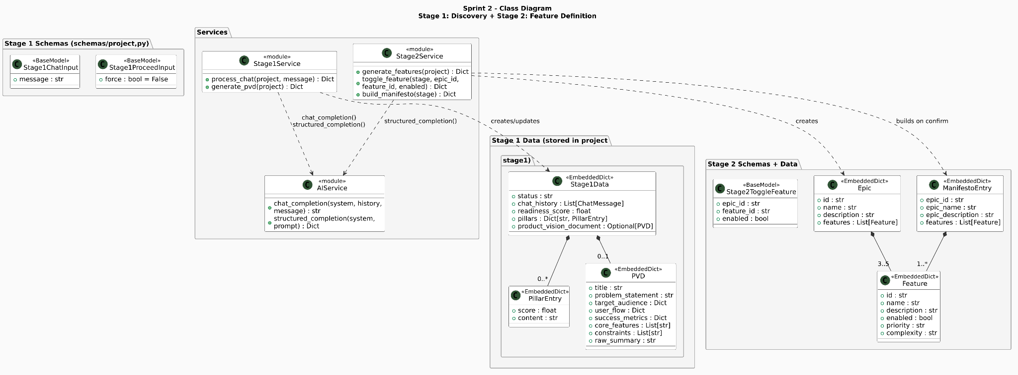
Sprint 3 - Stages 3-5 (5 days)

Goals
- Backlog generation with INVEST scoring
- Interactive UI with toggle and move for AC/FC editing
- Architecture generation (tech stack, ERD, API endpoints)
- UI prototype generation and style refinement

Deliverables
Task | Owner | Status
Stage 3 backlog generation endpoint | Backend Lead | Done
Stage 3 story update (status, AC, FC) | Backend Lead | Done
Stage 4 architecture generation and swap endpoint | Backend Lead | Done
Stage 5 UI view generation endpoint | Backend Lead | Done
Stage 5 style refinement (PATCH /stage/5/refine) | Backend Lead | Done
Frontend: interactive board | Frontend Lead | Done
Frontend: selection with AC/FC edit | Frontend Lead | Done
Frontend: Mermaid ERD rendering | Frontend Lead | Done
Frontend: iframe sandbox preview for Stage 5 | Frontend Lead | Done

Sprint 4 - Stages 6-7 and integration (1-2 week)

Goals
- Master Build Manifest generation
- Code and test generation with background task queue
- ZIP packaging and S3 upload
- End-to-end pipeline integration and testing

Deliverables
Task | Owner | Status
Stage 6 implementation plan generation | Backend Lead | Done
Stage 7 forge pipeline (code gen, test gen, zip) | Backend Lead | In Progress
AI test review report generation | Backend Lead | In Progress
Frontend: Stage 7 progress bar with step labels | Frontend Lead | In Progress
Frontend: Download button for ZIP | Frontend Lead | In Progress
End-to-end Playwright test (full 7-stage flow) | QA | In Progress

2. System Design

2.1 System architecture
MVP Forge uses a hybrid architecture. The Next.js frontend handles all UI rendering and state management. The FastAPI backend manages business logic, LLM orchestration, and MongoDB persistence. They communicate exclusively via REST API calls with JSON payloads.

Component | Responsibility
Next.js 16 (Frontend) | 7-stage dashboard UI, Kanban board, iframe screen preview, file explorer, Mermaid diagram rendering
FastAPI (Backend) | REST API routing, JWT validation, LLM prompt management, stage state machine, result storage
LangChain, LangGraph | LLM chain construction (ChatGroq), structured output, message history building
Groq (LLM API) | Inference via langchain-groq. Model: llama-3.1-8b-instant. Configurable via AI_MODEL env var.
MongoDB (Beanie ODM) | Single project document stores all 7 stage payloads as embedded Dict fields

2.2 AI Service Architecture
All LLM interactions are centralised in app/services/ai_service.py. Three utility functions handle all LLM communication:

Function | Purpose | Usage
chat_completion(system, history, message) | Multi-turn conversation. Reconstructs LangChain message objects from chat_history dict list. | Stage 1 discovery chat
structured_completion(system, prompt) | Single-turn call that mandates JSON-only response. Strips markdown fences. Calls json.loads(). | All generative stages (2-7)
single_completion(system, prompt) | Single-turn call returning raw string. No JSON enforcement. | Stage 5 HTML generation, Stage 7 code generation

2.3 Database design
Two collections exist in the mvpforge MongoDB database. No foreign key enforcement. owner_id in projects is a soft reference to users._id.

Collection: users

Field | Type | Notes
_id | ObjectId | Auto-generated by MongoDB
email | String | Unique. Indexed via Beanie Indexed().
username | String | Unique. Indexed via Beanie Indexed().
full_name | String | -
hashed_password | String | bcrypt hash. Never stored as plaintext.
is_active | Boolean | Default: true. Inactive users cannot log in.
is_verified | Boolean | Default: false. Email verification not yet implemented.
avatar_url | String | Optional
bio | String | Optional
created_at | DateTime | UTC. Set on insert.
updated_at | DateTime | UTC. Updated on every write.

Collection: projects
Field | Type | Notes
_id | ObjectId | Auto-generated by MongoDB
owner_id | String | Soft reference to users._id
name | String | Project name. Unique per user (enforced at application level).
description | String | Optional
current_stage | Integer | 1 to 7. Advances via max(current, next) never goes backward.
stage1 | Dict / null | Status, chat_history, readiness_score, pillars, product_vision_document
stage2 | Dict / null | Status, epics[ ], selected_features_manifesto[ ]
stage3 | Dict / null | Status, user_stories[ ], backlog {draft[ ], confirmed[ ]}
stage4 | Dict / null | tech_stack, api_endpoints, database_schema, erd_mermaid, system_diagram, architecture_decisions, status
stage5 | Dict / null | design_system, screens[ ], status
stage6 | Dict / null | project_name, tech_stack, directory_structure, tasks[ ], build_order[ ], env_vars, setup_commands, run_commands, status, validation
stage7 | Dict / null | status, generated_files[ ], test_cases[ ], test_report {total, passed, failed, coverage}
created_at | DateTime | UTC
updated_at | DateTime | UTC. Updated on every stage write.

2.4 API design
All endpoints are prefixed with /api/. Authentication uses Bearer JWT token in the Authorization header.

Method | Endpoint | Auth | Description
POST | /api/auth/register | No | Register new user. Returns JWT + UserResponse.
POST | /api/auth/login | No | Login via email or username. Returns JWT and UserResponse.
GET | /api/auth/me | Yes | Get current user profile.
PATCH | /api/auth/me | Yes | Update profile (full_name, bio, avatar_url).
GET | /api/users/ | Yes | List users (admin).
GET | /api/projects/ | Yes | List authenticated user's projects.
POST | /api/projects/ | Yes | Create a project. Returns ProjectResponse.
GET | /api/projects/{id} | Yes | Get project with all stage data.
PUT | /api/projects/{id} | Yes | Update project name/description.
DELETE | /api/projects/{id} | Yes | Delete project.
POST | /api/projects/{id}/stage1/chat | Yes | Send discovery chat message.
POST | /api/projects/{id}/stage1/proceed | Yes | Generate PVD and advance to Stage 2.
POST | /api/projects/{id}/stage2/generate | Yes | Generate epics and features from PVD.
PATCH | /api/projects/{id}/stage2/feature | Yes | Toggle feature enabled/disabled.
POST | /api/projects/{id}/stage2/confirm | Yes | Build a manifesto and advance to Stage 3.
POST | /api/projects/{id}/stage3/generate | Yes | Generate backlog via 3-phase LLM pipeline.
PATCH | /api/projects/{id}/stage3/story/move | Yes | Move story to draft or confirmed.
PATCH | /api/projects/{id}/stage3/story/edit | Yes | Edit a story field inline.
POST | /api/projects/{id}/stage3/story/regenerate | Yes | Regenerate story with prompt.
POST | /api/projects/{id}/stage3/confirm | Yes | Confirm backlog, advance to Stage 4.
POST | /api/projects/{id}/stage4/generate | Yes | Generate full architecture package.
POST | /api/projects/{id}/stage4/modify | Yes | Modify architecture with natural-language prompt.
POST | /api/projects/{id}/stage4/confirm | Yes | Confirm architecture, advance to Stage 5.

3. Object Design

Key Design Patterns Used
Pattern | Where Applied
Service Layer | One service file per stage (stage1_service.py through stage7_service.py) encapsulates all LLM and business logic. Routes are thin wrappers.
Dependency Injection | get_owned_project() FastAPI dependency used in every stage route. It fetches the project and verifies ownership in one place.
Centralised AI Service | ai_service.py provides chat_completion, structured_completion, and single_completion all stage services import from this module.
Embedded Document Pattern | All stage data is stored as Dict fields inside the Project document. No separate stage collections or joins required.
Soft-Reference Owner | project.owner_id is a string reference (not a DBRef) to users._id. Ownership checked at application level in get_owned_project().
Batch + Rate-limit Pattern | Stage 3 and Stage 6 use chunk_list() to process in batches of 5 with asyncio.sleep delays between calls (RATE_LIMIT_DELAY=5s) to avoid Groq rate limits.
UUID Normalisation | Stage 6 calls normalize_task_ids() after generation to replace any duplicate or invalid task IDs with fresh UUIDs.
Manifest Validation Gate | Stage 6 confirm endpoint calls validate_manifest() and blocks if errors > 0. Warnings are non-blocking.

Stage State Machine
Stage | Entry Condition | Exit Condition | Failure Handling
1 | Project created, current_stage=1 | readiness_score >= 0.85 AND /proceed called (or force=true) | LLM error: returns last known score and chat history preserved
2 | stage1.status == 'completed' | /confirm called builds manifesto, current_stage=3 | LLM retry, user can re-call /generate
3 | stage2.status == 'completed' | /confirm called, current_stage=4 | Per-batch retry (MAX_RETRIES=2), user can regenerate individual stories
4 | stage3.status == 'completed' | /confirm called, current_stage=5 | LLM retry, user can call /modify with prompt
5 | stage4.status == 'completed' | /confirm called, current_stage=6 | Per-screen retry, user can call /screen/edit with prompt
6 | stage5.status == 'completed' | /confirm called with no validation errors, current_stage=7 | validate_manifest() blocks confirm if errors exist, user edit tasks or manifest
7 | stage6.status == 'completed' | run_generation() completes, stage7.status='completed' | Individual file generation failures stored with error field, pipeline continues

LLM Interaction Model
Stage | LLM Calls | Method | Key Outputs
Stage 1 chat | 1 per message | chat_completion | AI response text, score pillar block
Stage 1 proceed | 1 | structured_completion | PVD JSON (title, problem_statement, target_audience, user_flow, success_metrics, core_features, constraints, raw_summary)
Stage 2 generate | 1 | structured_completion | Epics with Features JSON
Stage 3 generate | 3 passes × N batches | structured_completion | Phase 1: stories,  Phase 2: criteria,  Phase 3: INVEST scores
Stage 3 regenerate | 1 per story | structured_completion | Updated story JSON
Stage 4 generate | 5 sequential calls | structured_completion | tech_stack, api_endpoints, database_schema, diagrams, architecture_decisions
Stage 4 modify | 1 | structured_completion | Full updated architecture JSON
Stage 5 generate | 1 (plan) + N (screens) | structured_completion + single_completion | design_system, N raw HTML strings
Stage 5 edit | 1 per edit | single_completion | Updated HTML string
Stage 6 generate | 5 + N task batches | structured_completion | meta, directory, task batches, build_order, setup
Stage 7 generate | 1 per file + 1 per criterion | single_completion + structured_completion | Source code strings + TestCase JSONs

4. Implementation Status

Implemented backend
Feature | Stage | Status
JWT auth middleware (get_current_user) on all protected routes | All | Done
User register, login, get, update routes (/api/auth/* and /api/users/) | Auth | Done
Project CRUD routes (/api/projects/) | Projects | Done
Stage 1 chat and proceed routes + Stage1Service | 1 | Done
Stage 2 generate, feature-toggle, confirm routes + Stage2Service | 2 | Done
Stage 3 generate (3-phase batch), move, edit, regenerate, confirm + Stage3Service | 3 | Done
Stage 4 generate (5-call pipeline), modify, confirm + Stage4Service | 4 | Done
Stage 5 generate (design system + HTML screens), edit, approve, confirm + Stage5Service | 5 | Done
Stage 6 generate, validate, edit-task, edit-manifest, confirm + Stage6Service | 6 | Done
Stage 7 generate (code + tests + report), file list, file get + Stage7Service | 7 | Done
Stages 5–7 router wiring in main.py | 5–7 | Partial stage_5_router through stage_7_router not yet imported in main.py

Planned for backend
Feature | Stage | Notes
Wire stage5, stage6, stage7 routers in main.py | 5-7 | Currently only stages 1-4 are included_router in main.py.
Rate limiting on LLM endpoints | All | No per-user or per-endpoint rate limiting implemented.
ZIP packaging and download endpoint | 7 | zip_url field exists in Stage7Data but no zip generation or download route implemented.
S3 or local file storage for ZIPs | 7 | zip_url remains null in all current outputs.
Email verification flow | Auth | is_verified field exists but verification is not triggered.

Frontend Status
Feature | Stage | Status
Login and Register pages (/login, /register) | Auth | Done
Auth store (Zustand authStore.ts) with JWT persistence in localStorage | Auth | Done
Project dashboard (list, create, delete) | Projects | Done
Stage 1 chat interface with readiness score display | 1 | Done
Stage 2 feature toggle card UI | 2 | Done
Stage 3 Kanban board | 3 | Done
Stage 4 architecture view with Mermaid diagram rendering | 4 | Done
Stage 5 iframe sandboxed screen preview + edit prompt | 5 | Done
Stage 6 Master Plan task list with validation status | 6 | Done
Stage 7 generated file explorer + test report | 7 | Done
StageSidebar navigation component | All | Done
Profile and Settings pages | Auth | Done

Artifacts

Project Folder Structure
Path | Contents
backend/main.py | FastAPI app entry point. Lifespan hooks for DB connect/disconnect. CORS middleware. Routes for stages 1-6 included.
backend/app/config.py | Pydantic BaseSettings. Reads MONGODB_URL, DB_NAME, JWT_SECRET_KEY, GROQ_API_KEY, AI_MODEL, ANTHROPIC_API_KEY, OPENAI_API_KEY, CORS_ORIGINS, ENVIRONMENT from .env.
backend/config/settings.py | Alternate settings module (used in main.py). Includes HOST, PORT, LOG_LEVEL, READINESS_SCORE_THRESHOLD, SESSION_TIMEOUT.
backend/app/database.py | Motor + Beanie initialisation. connect_db() and close_db() for lifespan.
backend/app/models/user.py | User Beanie Document + UserCreate, UserLogin, UserUpdate, UserOut schemas.
backend/app/models/project.py | Project Beanie Document + ProjectCreate, ProjectUpdate, ProjectOut schemas.
backend/app/schemas/project.py | Pydantic input schemas for stage routes: Stage1ChatInput, Stage1ProceedInput, Stage2ToggleFeature, Stage3StoryMove, Stage3StoryEdit, Stage3RegenerateStory, Stage4ModifyRequest, and more.
backend/app/schemas/user.py | UserRegister, UserLogin, UserUpdate, UserResponse, TokenResponse, TokenData.
backend/app/routes/auth.py | POST /auth/register, POST /auth/login, GET /auth/me, PATCH /auth/me.
backend/app/routes/users.py | User management endpoints.
backend/app/routes/projects.py | Project CRUD endpoints + project_to_response() helper.
backend/app/routes/stage1.py–stage7.py | One file per stage with get_owned_project() dependency. All stage endpoints.
backend/app/services/ai_service.py | get_llm(), build_messages(),  chat_completion(),  structured_completion(),  single_completion().
backend/app/services/stage1_service.py | process_chat(), generate_pvd().
backend/app/services/stage2_service.py | generate_features(), toggle_feature(), build_manifesto().
backend/app/services/stage3_service.py | generate_backlog() (3-phase), move_story(), edit_story_field(), regenerate_story(), confirm_backlog().
backend/app/services/stage4_service.py | generate_architecture() (5-call), modify_architecture(), confirm_architecture().
backend/app/services/stage5_service.py | generate_ui_screens(), edit_screen(), approve_screen(), confirm_ui().
backend/app/services/stage6_service.py | generate_master_plan(), validate_manifest(), edit_task(), edit_manifest(), confirm_manifest().
backend/app/services/stage7_service.py | run_generation(), generate_file(), generate_tests(), detect_language().
backend/app/middleware/auth.py | hash_password(), verify_password(), create_access_token(), get_current_user() FastAPI dependency.
backend/app/utils/security.py | Security helpers.
backend/requirements.txt | All Python dependencies with pinned versions.
frontend/src/app/ | Next.js App Router pages: /, /dashboard, /project/[id], /profile, /settings, /(auth)/login, /(auth)/register.
frontend/src/components/stages/ | Stage1Discovery through Stage7Forge React components.
frontend/src/components/layout/ | Navbar.tsx, StageSidebar.tsx.
frontend/src/store/authStore.ts | Zustand auth store with JWT token, user, and login/logout/register actions.
frontend/src/store/projectStore.ts | Zustand project store with fetchProjects, fetchProject, createProject, deleteProject, updateCurrentProject.
frontend/src/lib/api.ts | Axios-based API clients: projectsApi, stage1Api through stage7Api. Attaches JWT from localStorage on each request.
frontend/src/types/index.ts | TypeScript type definitions.

Security Decisions
Decision | Rationale
bcrypt for password hashing | Industry standard. Salted automatically.
JWT HS256 | Stateless authentication. No server-side session store needed. Expiry configurable via ACCESS_TOKEN_EXPIRE_MINUTES.
HTTPBearer dependency on all protected routes | get_current_user() is a FastAPI Dependency injected into every route that requires auth. Uniform enforcement.
Ownership check in get_owned_project() | Every stage route verifies project.owner_id == current_user.id. Prevents cross-user data access.
Structured JSON enforcement on LLM outputs | structured_completion() appends a JSON-only instruction to the system prompt. Prevents malformed LLM output from crashing downstream stages.
iframe sandbox for Stage 5 HTML | LLM-generated HTML is rendered in isolation to prevent XSS.
hashed_password excluded from UserResponse | The response schema never includes the password field, even accidentally.

UI/UX Design Decisions
Stage | UI Component | Key Interaction
Stage 1 | Chat interface | Scrolling message list. Readiness score shown as per-pillar progress indicators. Proceed button disabled until score >= 0.85.
Stage 2 | Feature toggle cards | Epics grouped as accordion sections. Each Feature has an enabled switch (Radix UI Switch). Confirm builds the manifesto.
Stage 3 | Kanban board | Two columns: Draft and Confirmed.
Stage 4 | Architecture panels | Tech stack list, API endpoint table, DB schema, and Mermaid diagram rendered via mermaid.js. Modify prompt input below.
Stage 5 | Screen previewer | iframe with sandbox attribute renders generated HTML screens. Edit prompt below each screen. Approve button per screen.
Stage 6 | Task manifest viewer | Task list grouped by component type. Validation error/warning badges. Edit task inline.

